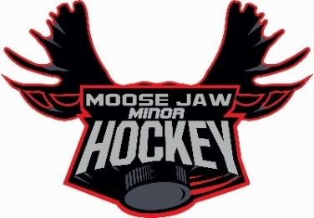
306
-
693
-
admin@mjhockey.com
4900

www.moosejawmiorhockey.com

370
Saskatchewan St. W. Moose Jaw, Sk

S6H 2T2

U11A, U13A, U15A, U18A COACH APPLICATIONS

The Moose Jaw Minor Hockey Association (MJMHA) is accepting applications for the position of ”A” Head Coach’s for the 2022/2023 season. The A teams play in the Hockey Regina League.

MJMHA is seeking an individual who wants to develop young athletes by instilling the values of MJMHA including hard work, commitment, and determination in a positive and fun environment. Candidates should be able to demonstrate prior coaching experience hockey knowledge, good communication skills, and good organizational skills.

Head Coach must have, or be able to achieve the following certifications:
- Level 2 Coach
- Respect in Sport
- Checking Certification
- Goalie Coach Certification (or Assistant Coach must have)
- Planning a Safe Return to Hockey
- A current Vulnerable Sector Check (VSC)
- A valid driver’s license
The roles and responsibilities of the job include:
- Work with the MJMHA Board of Directors/Tier Director and Development Director on an as needed basis to maintain development programs;
- Attend the U13 Fall Evaluations and continue to evaluate players through an exhibition series;
- Prepare and deliver a season plan including off ice requirements, practice plans and game line ups;
- Select qualified assistant coaches, team manager, and other team personnel as needed;
- Attend the MJMHA Coach’s Meetings as required;
- Develop an ongoing program that provides a consistent experience for players and parents;
- Liaison with other AA coaches in the Association to develop long term program development; and
- Assist in the fall development camps as required.
MJMHA will accept applications from both independent coaches as well as parent coaches where applicable. If you are interested in this role, please submit your expression of interest to admin@mjhockey.com along with a resume of your qualifications by June 15th, 2022. Only those being considered for the position will be contacted for an interview.

